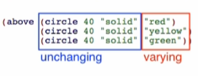

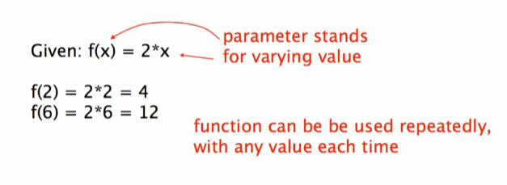

Function Syntax

* (define ([func name] [parameter])

(expression))



Evaluation:

 ->  -> 

Implementing the ‘bulb’ function

Function: 

From this: 

To this: 

Result: 